On-Campus Student Employment FAQ’s

How can I tell what positions are open on campus?
All on-campus student employment positions are posted through Handshake. In your Handshake account, click on “Jobs” on the top of your screen. Then select “on-campus” as a filter. You will see a list of all on-campus positions.
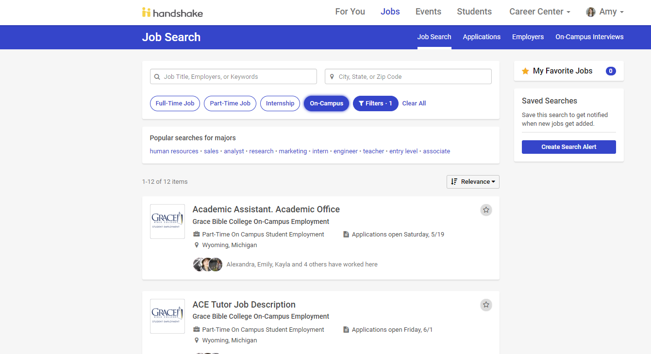

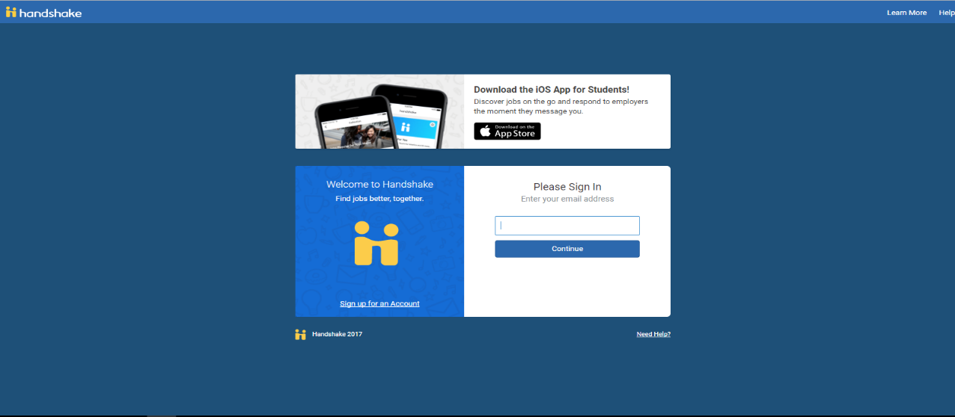
How do I create a Handshake account?

- Go to app.joinhandshake.com
- Type in your GBC email address (you do not need to create an account)
- Once asked for a password, click “Forgot your password?”
- Click “Reset Password”
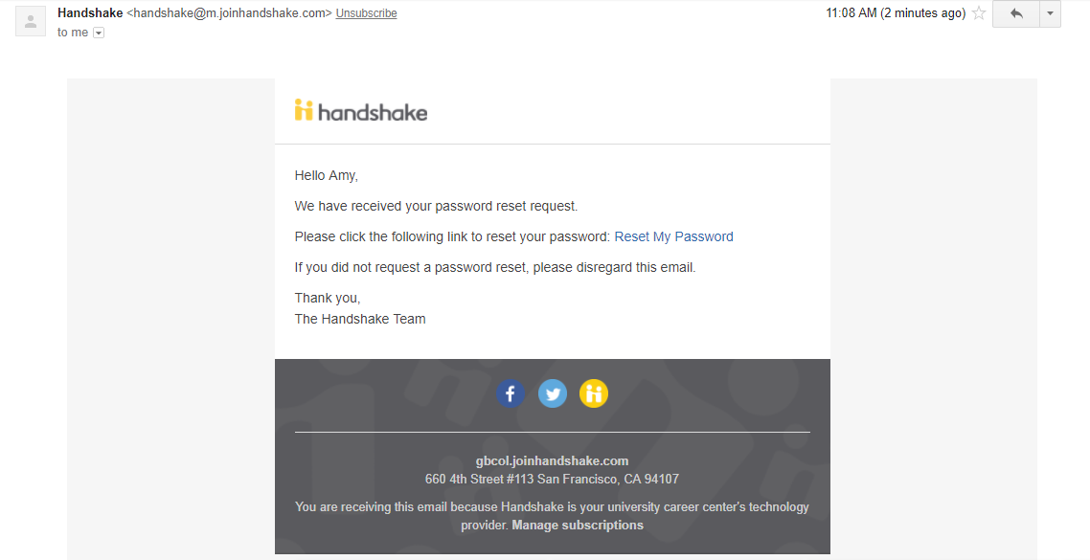
- An email will be sent with instructions

- Once your password has been reset, you can login into your Handshake account.

Where can I find the Student Application for Employment and the New Hire Paperwork?
Both of these documents are housed in Handshake. In your Handshake account, go under the Career Center tab on the top of your screen. Then click Resources. Both documents are accessible for you to download.

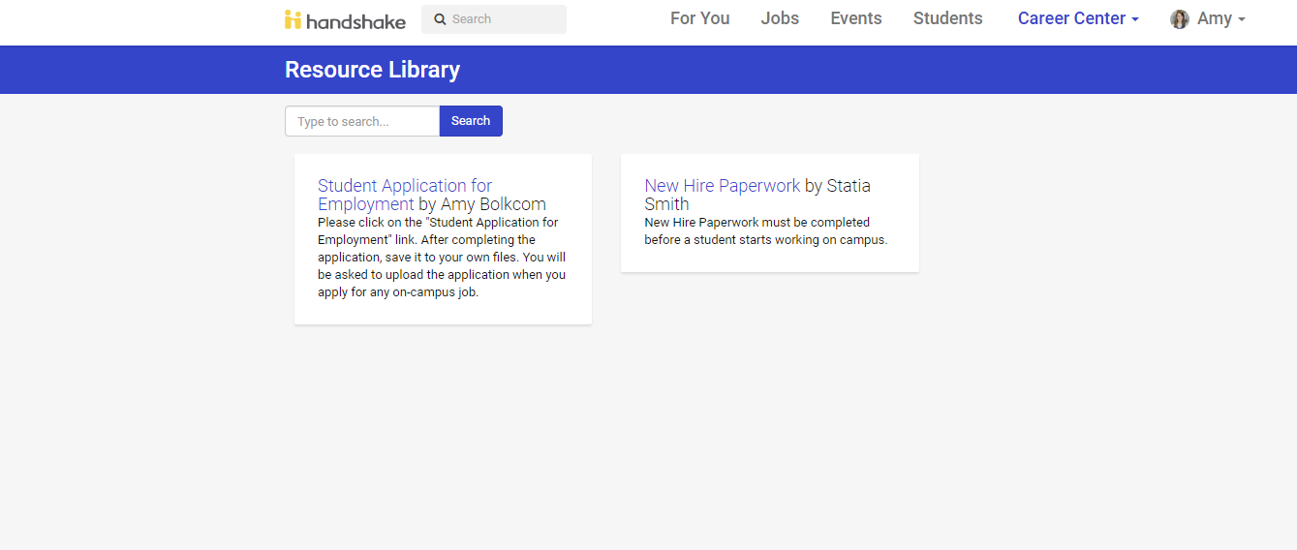

Will I have to interview for my position?
Yes. The Hiring Manager for the department you have applied for will contact you and schedule an interview. If you would like to do a practice interview or go over interviewing tips, please set up an appointment with the Career Services Office. You can schedule an appointment through Handshake by clicking on the Career Center tab at the top of your screen. Then click Appointments. The Career Services staff have their available appointment slots listed.

When will I know if I got hired for the position?
- If the department’s Hiring Manager wants to hire you, you will receive an Offer of Employment email from Statia Smith, Human Resource Specialist
- If the Hiring Manager does not wish to hire you, you will receive a notification of the decision from the hiring manager.

How long will it take for me to hear about the status of my application?
The timeframe will vary based on the department’s need in which you have applied.

Who should I contact if I need help with Handshake?
You can contact Amy Bolkcom, in the Career Services Office, at abolkcom@gbcol.edu

Who should I contact if I need help with the Hiring Process?
You can contact Statia Smith, in the Human Resources Department, at ssmith@gbcol.edu

