Mock Interview Questions

- Tell me about yourself…
- Why are you interested in this position?
- What excites you the most about the position? What would be most challenging?
- Why should we hire you?
- What are your greatest strengths?
- What is your greatest weakness?
- How has your past work experiences prepared you for this position?
- Describe your personality...
- How would you benefit the mission of our company?
- What is one of your greatest achievements?
- Where do you see yourself in 5 years?
- Why do you want to work for our company?
- What is your ideal work environment?

Behavior Scenario Questions
- When have you acted as a leader?
- Tell me about a time that you resolved conflict between team members
- When have you faced an obstacle? How did you overcome the obstacle to reach your goal?
- Describe your experience working with others from diverse backgrounds?
- Tell me about a time you were asked to do something that you were uncomfortable with. How did you handle the situation?
- Tell me about a time that you were adaptable in the face of change.
- When was a time that you took initiative to move a project forward?

Always come prepared with 5 - 10 questions. Make sure to ask at least 3.
- What does success look like in this job?
- What training will be provided?
- What have you found most enjoyable about working for the company?
- What gets you most excited about the company’s future?
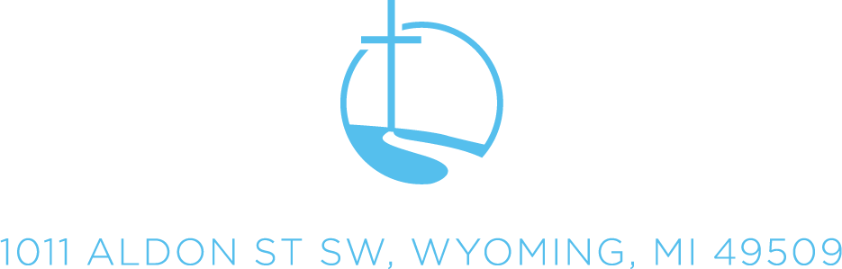
- What is the timeframe/process for making your hiring decision?

